micro:bit v2 Hardware Architecture

<https://microbit.org/get-started/user-guide/overview/>

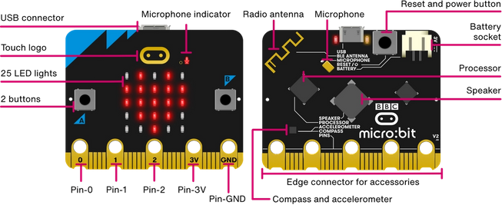

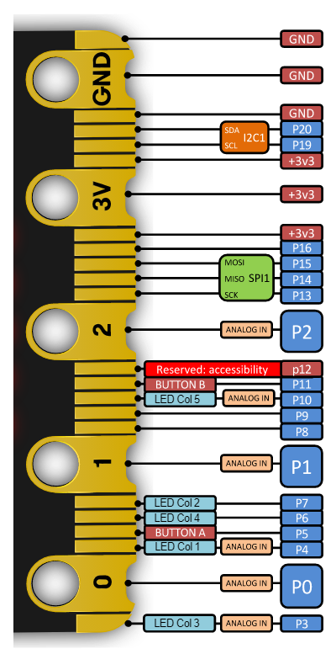

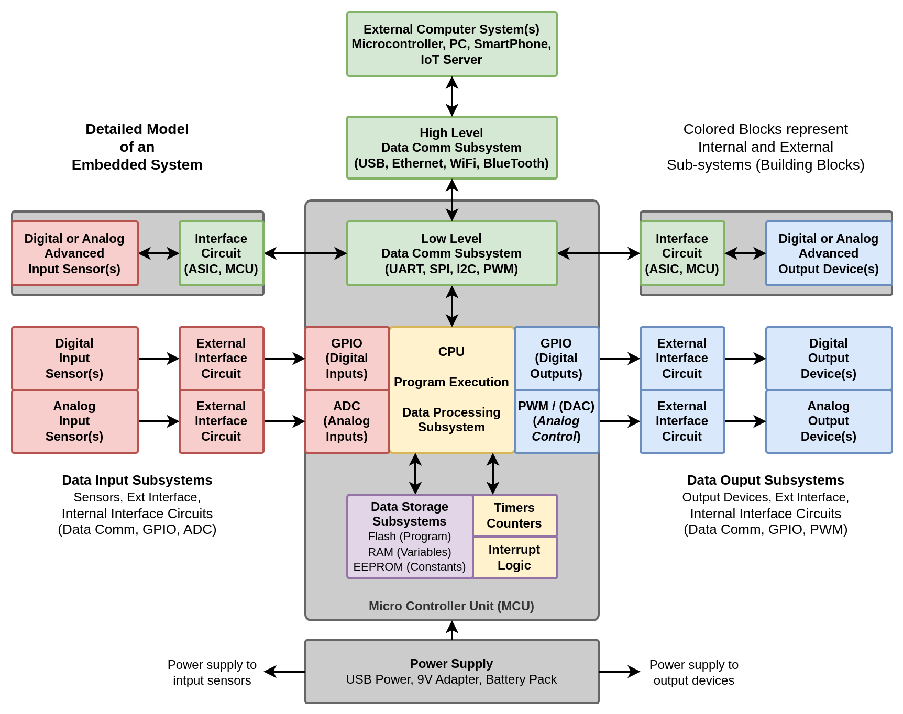

**Data Input Sub-systems:**

Advanced input sensors:

* Compass
* Accelerometer

Digital input sensors:

* Buttons A, B
* Touch sensor (logo)

Analog input sensors:

* Microphone
* MCU Temperature Sensor
* Light sensor (25 LEDs)

**Data Comm Sub-systems:**

High level data comm:

* Radio (RF Comm)
* Bluetooth
* USB

Low level data comm:

* UART, SPI, I2C, PWM

**Micro-controller Unit (MCU):**

nRF52833 (3.3V, 64 MHz, 32 bit)

**Data processing sub-systems:**

* Arm Cortex-M4 32 bit CPU with FPU

**Data storage sub-systems:**

* Flash ROM (512 kB)
* RAM (128 kB)

**Data Output Sub-systems:**

Digital output devices:

* LEDs (25) (5x5 matrix)

Analog output devices:

* Speaker

**Power Supply Sub-systems:**

* USB power (5V to 3.3V)
* Battery connector (3V battery)